**PRACTICAL NO: 1**

**Aim -** Create a network with three routers with RIPv2 and each router associated network will have minimum three PC. Show connectivity.

1. Align 9 end-devices as follows:

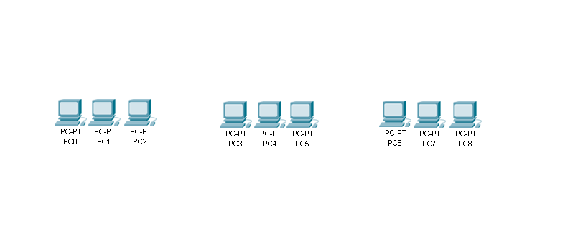

1. Set the DNS, Gateway and Fast Ethernet connections for all the PCs as follows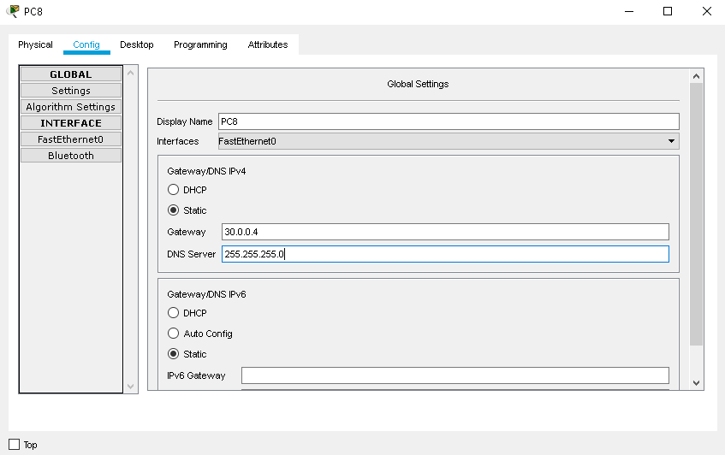 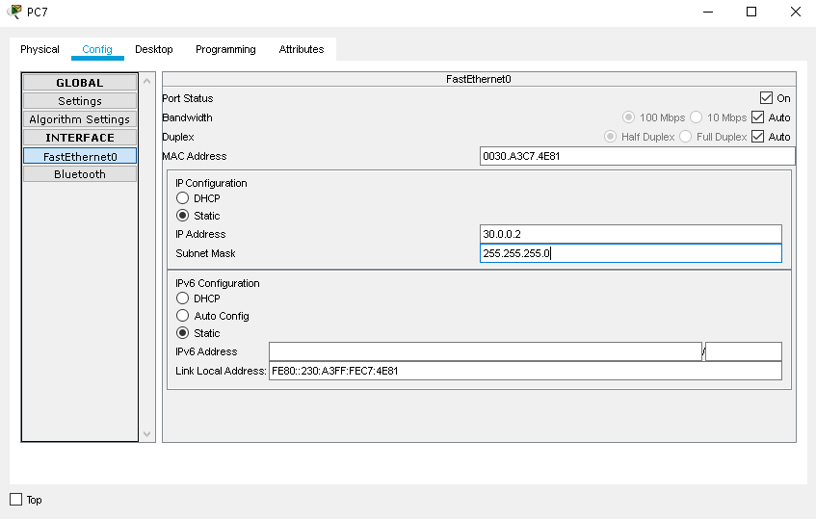

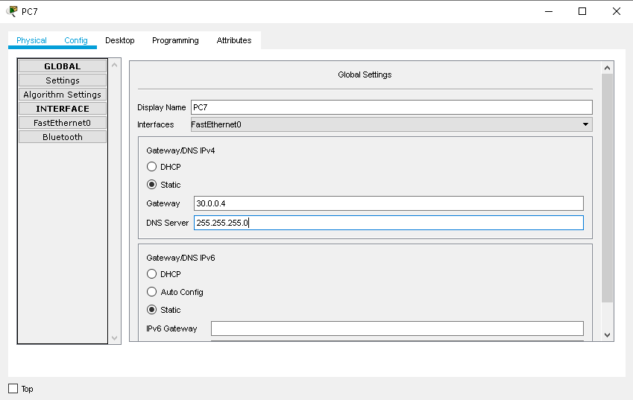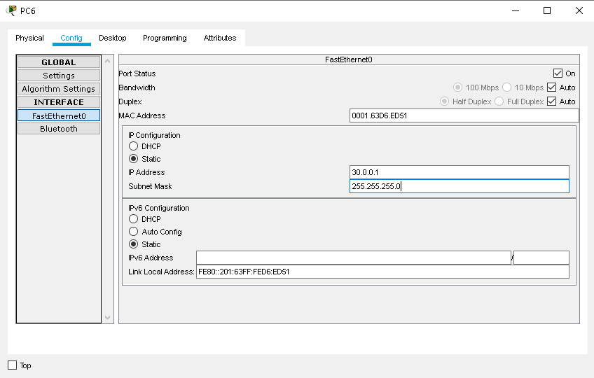

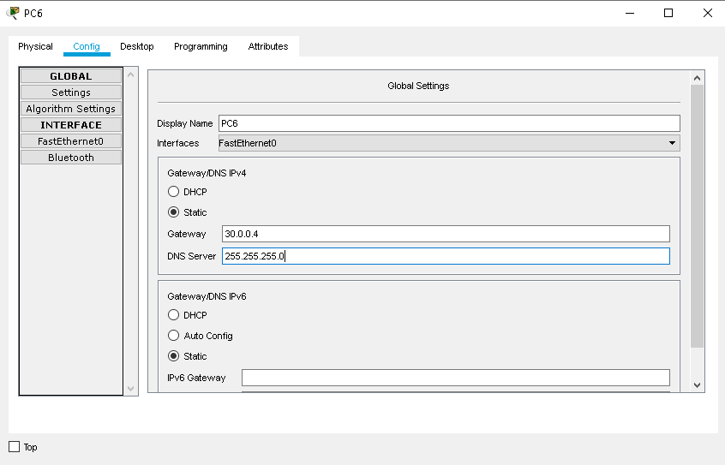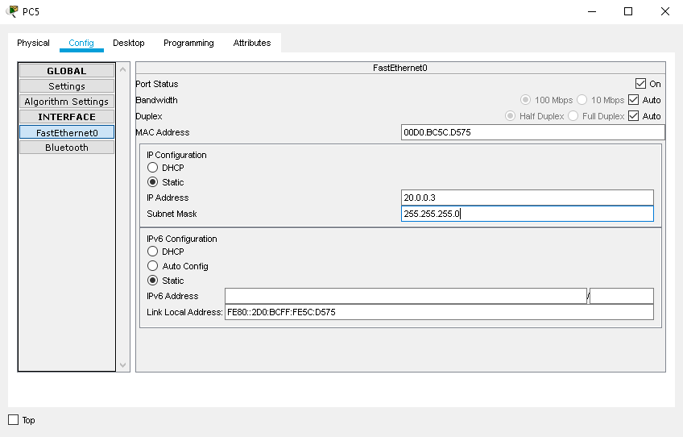

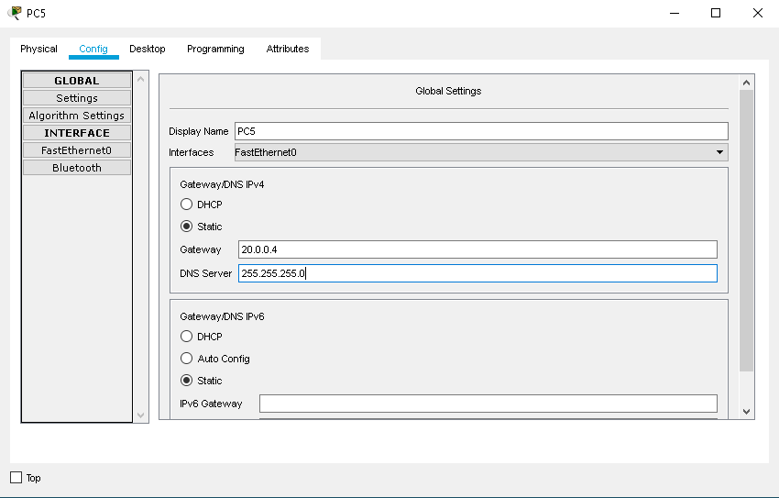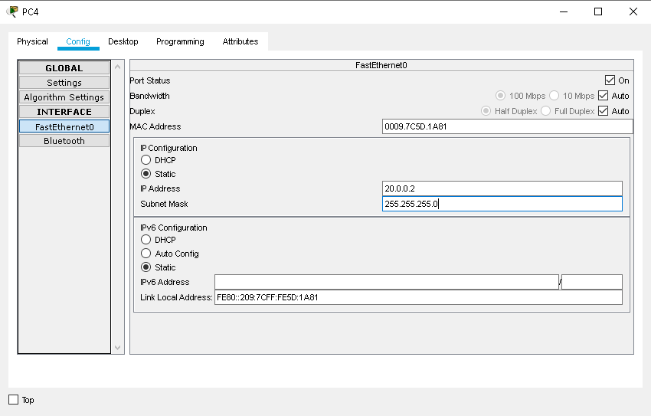

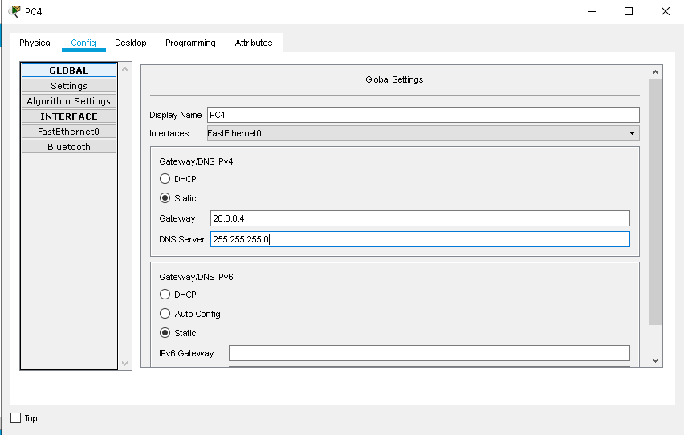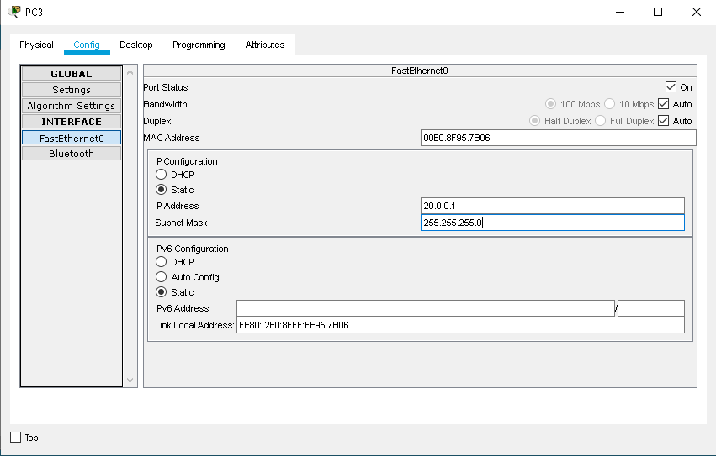

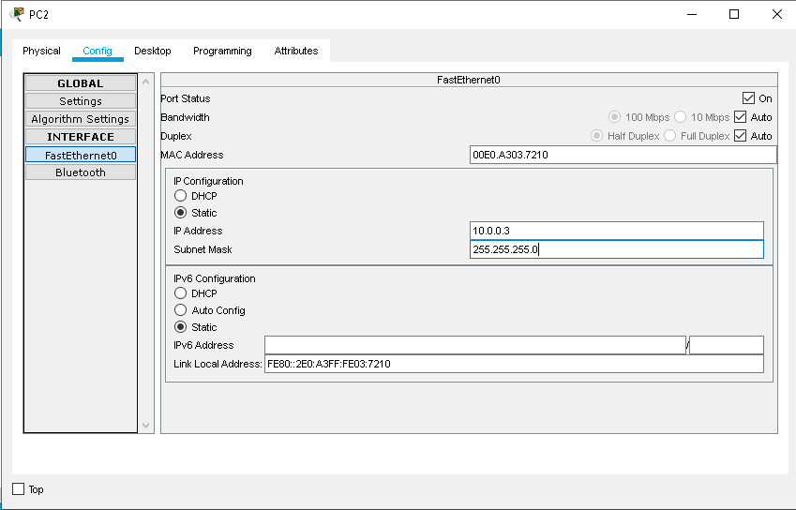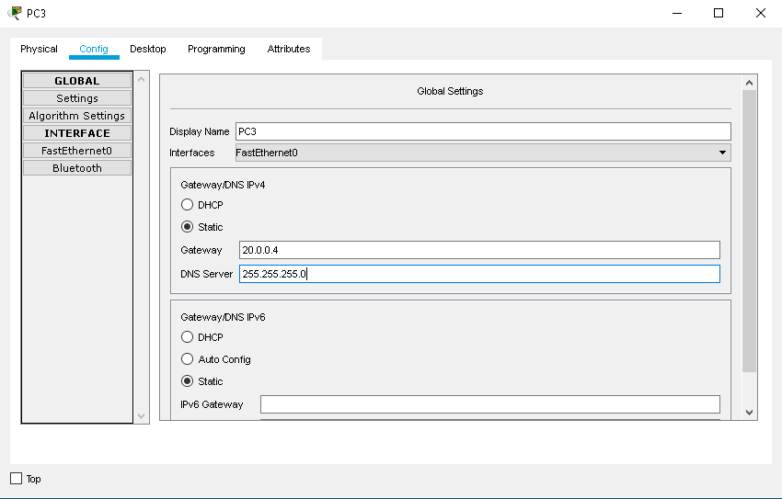

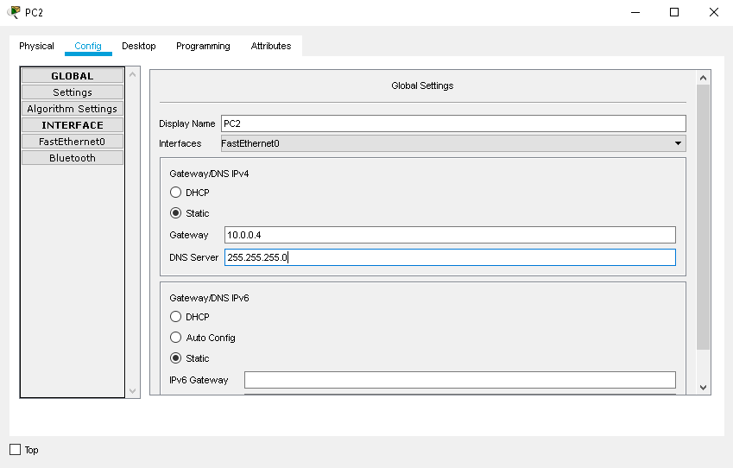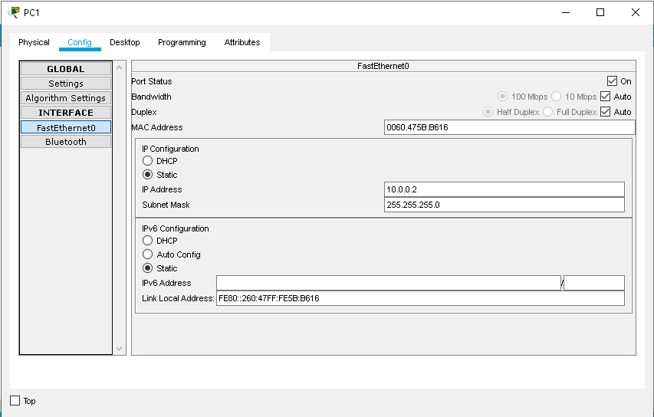

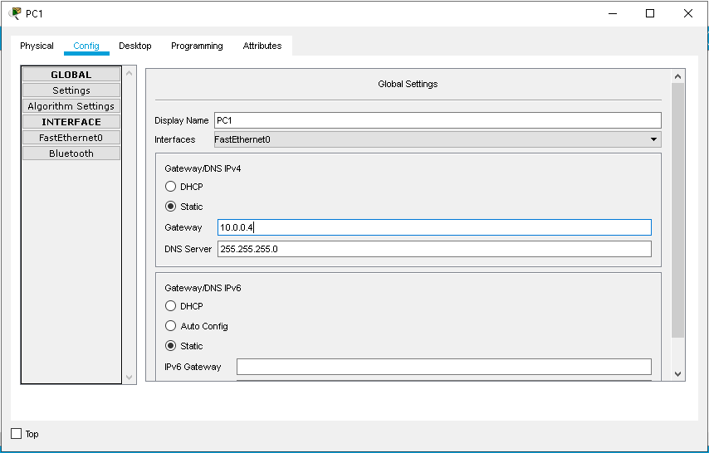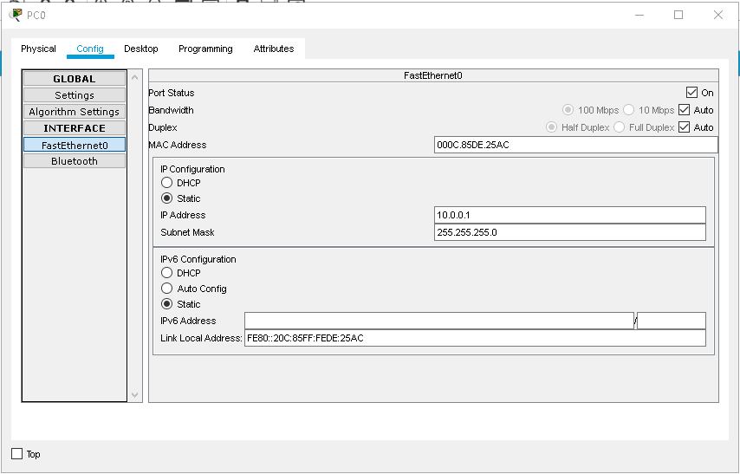

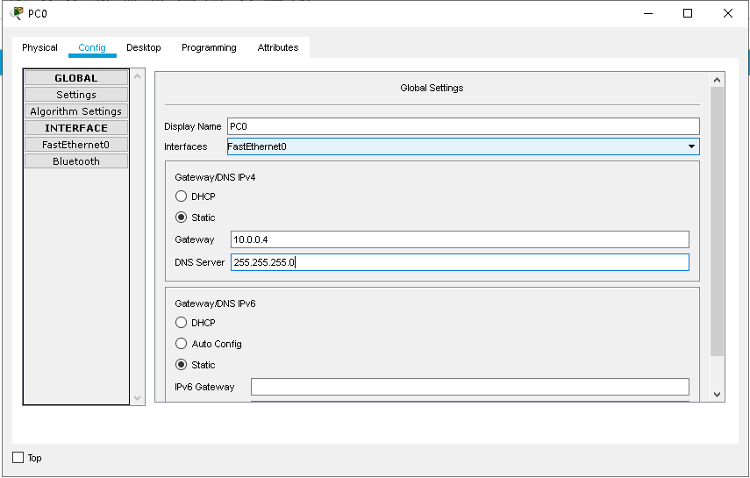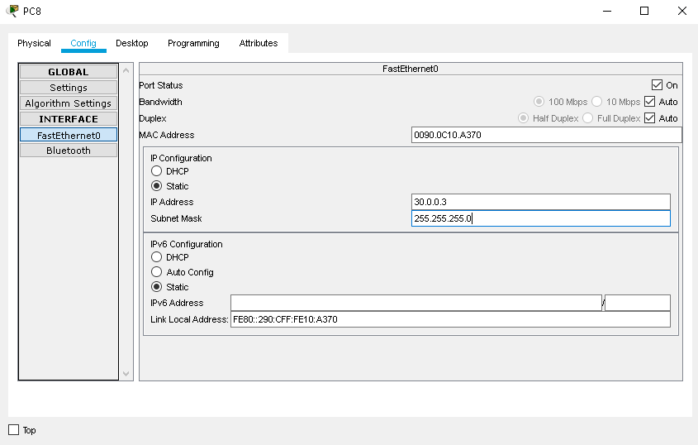

1. Add 3 Switches as follows: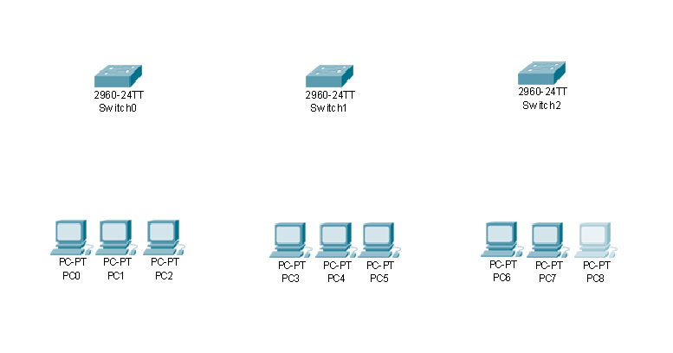
2. Add 3 Routers and connect all the components using Fast Ethernet connection as follows:

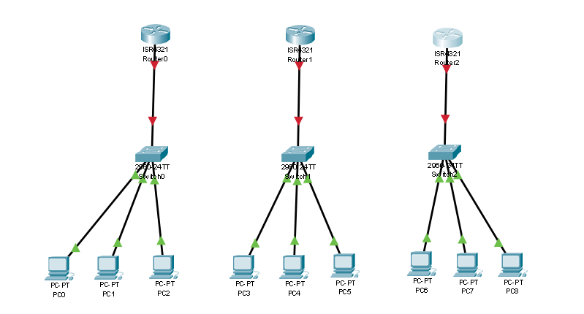

1. Power off each of the Routers and add the NIM-2T Module to all the Routers as follows:

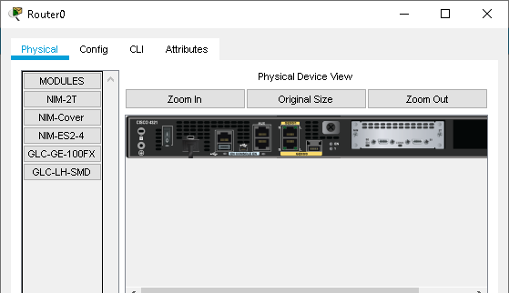

1. Connect the Routers using Serial DTE wires as shown:

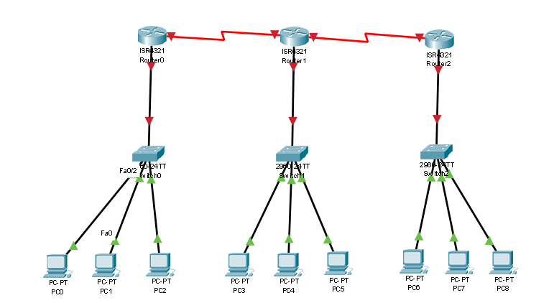

1. Configure Router 0 using the Command Line Interface as follows:

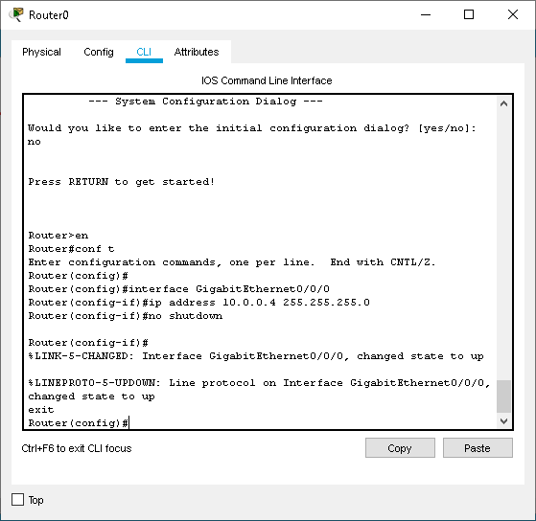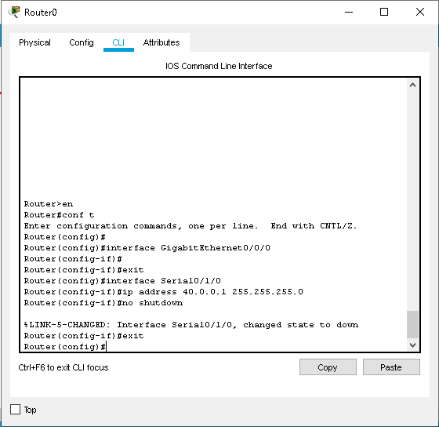

1. Configure Router 1 using the Command Line Interface as follows:

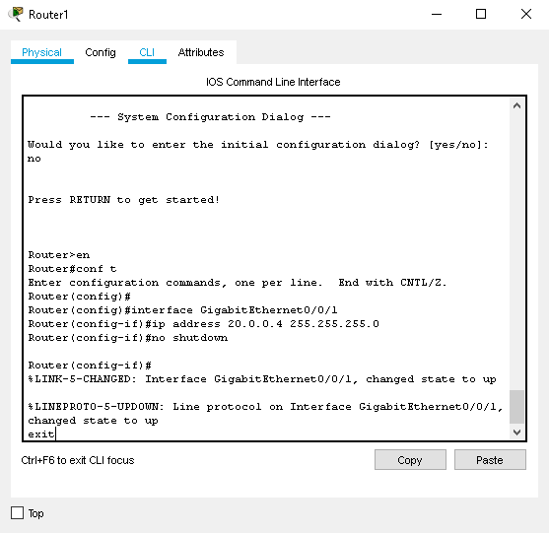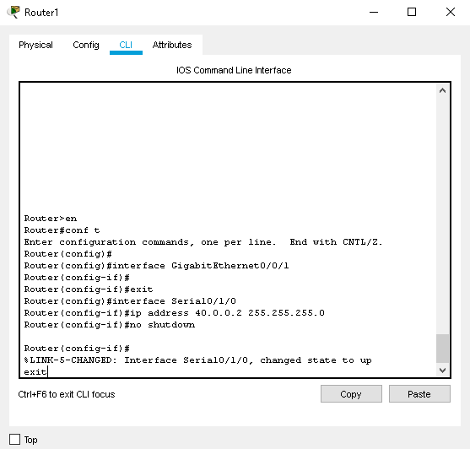

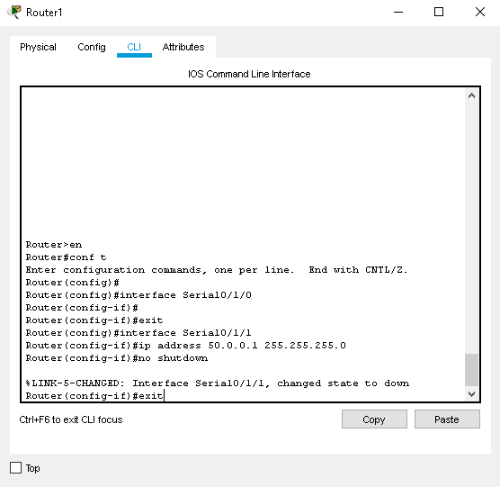

1. Configure Router 2 using the Command Line Interface as follows:

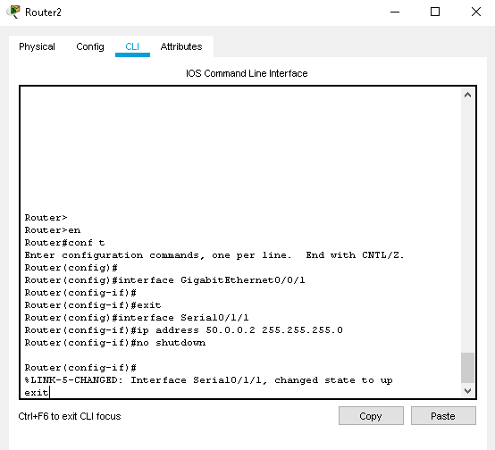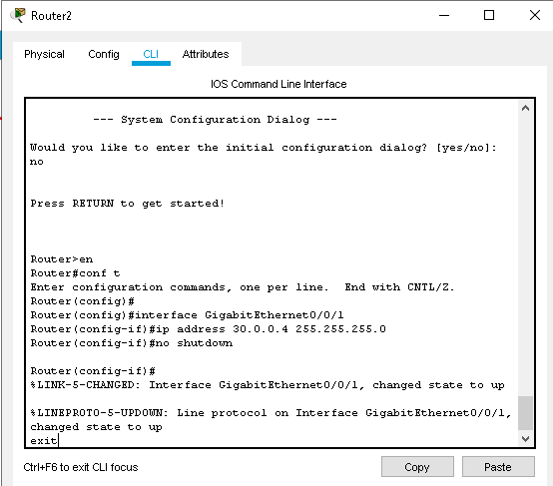

1. The Final connection will look as shown:

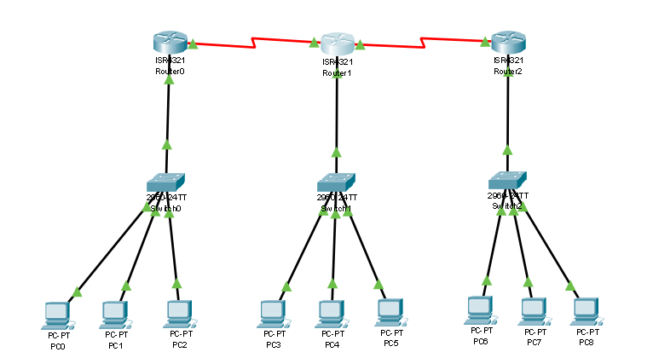

1. Note how intra-connection packet sending succeeds and inter-connection fails:

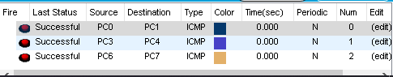

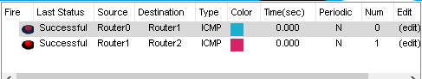

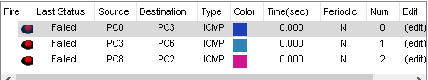

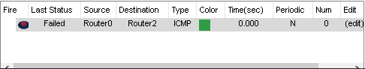

1. Configure RIP Routing in Router 0 as follows:

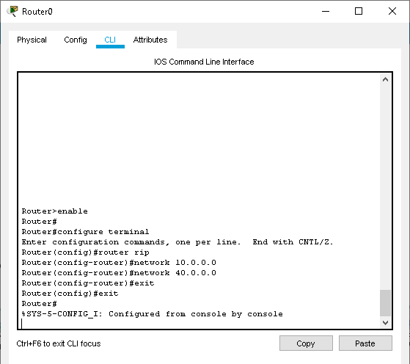

1. Configure RIP Routing in Router 1 as follows:

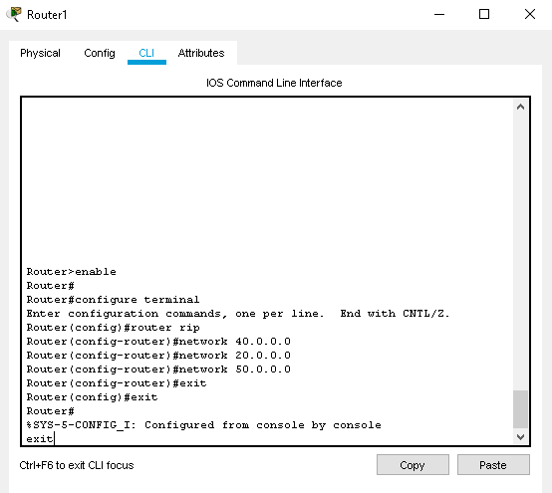

1. Configure RIP Routing in Router 2 as follows:

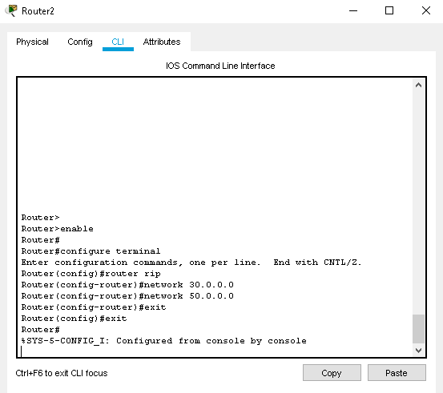

1. Sending packets after RIP routing gives the following result:

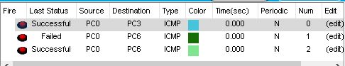

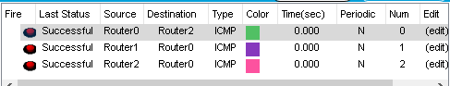

1. Finally, type ‘show ip route’ in the Router’s CLI to obtain the IP route results:

ROUTER 0

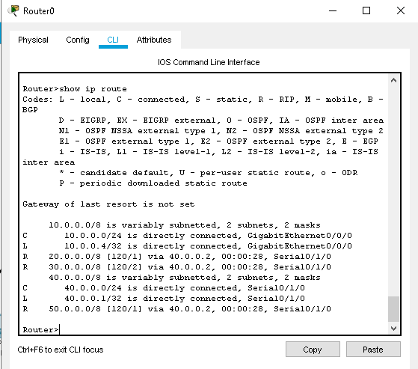

ROUTER 1

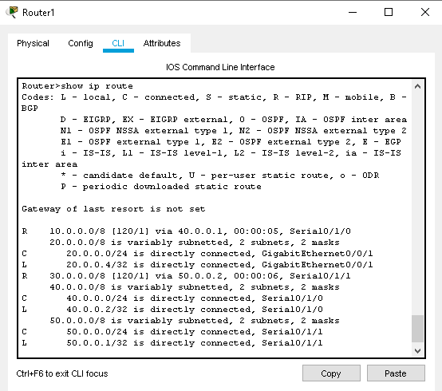

ROUTER 2

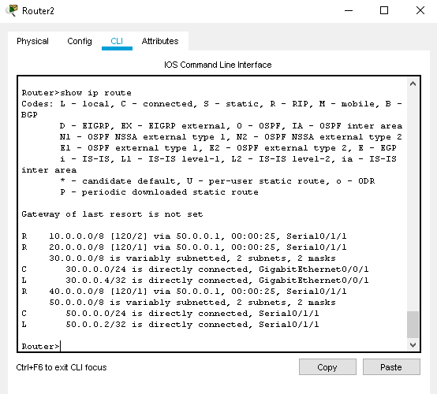

**CONCLUSION:** We have learnt to create a RIPv2 with three routers as shown above.

**PRACTICAL No: 2**

**Aim -** Create a network with three routers with OSPF and each router associated network will have minimum three PC. Show connectivity.

1. Align 9 end-devices as follows:



1. Set the DNS, Gateway and Fast Ethernet connections for all the PCs as follows: 

















1. Add 3 Switches as follows:
2. Add 3 Routers and connect all the components using Fast Ethernet connection as follows:



1. Power off each of the Routers and add the NIM-2T Module to all the Routers as follows:



1. Connect the Routers using Serial DTE wires as shown:



1. Configure Router 0 using the Command Line Interface as follows:



1. Configure Router 1 using the Command Line Interface as follows:

 



1. Configure Router 2 using the Command Line Interface as follows:



1. The Final connection will look as shown:



1. Note how intra-connection packet sending succeeds and inter-connection fails:









1. Configure OSPF Routing in Router 0 as follows:

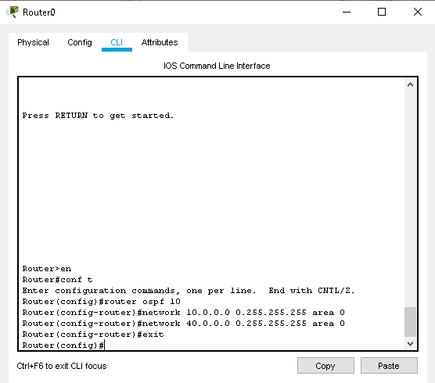

1. Configure OSPF Routing in Router 1 as follows:

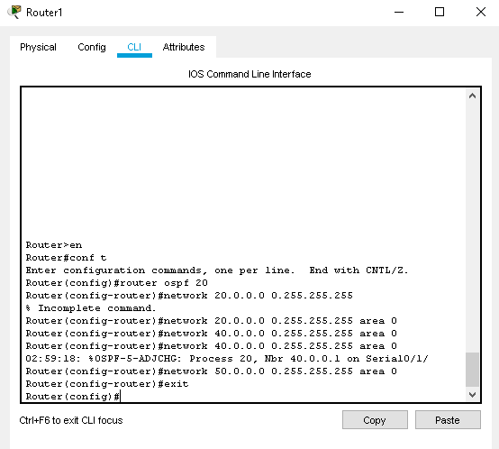

1. Configure OSPF Routing in Router 2 as follows;

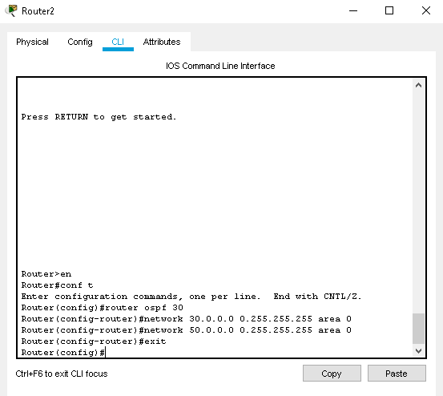

1. After successful OSPF configuration, send packets over the inter-connected network :





1. Finally, in every Router’s CLI, type ‘show ip route’ to get the connection details:

ROUTER 0

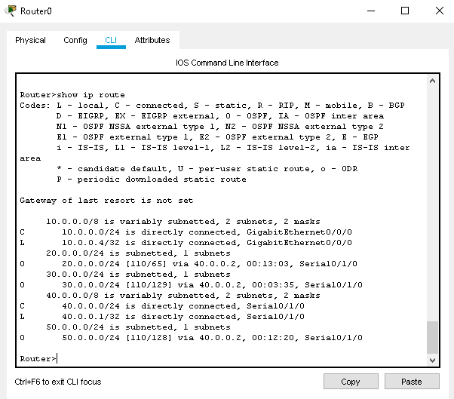

ROUTER 1 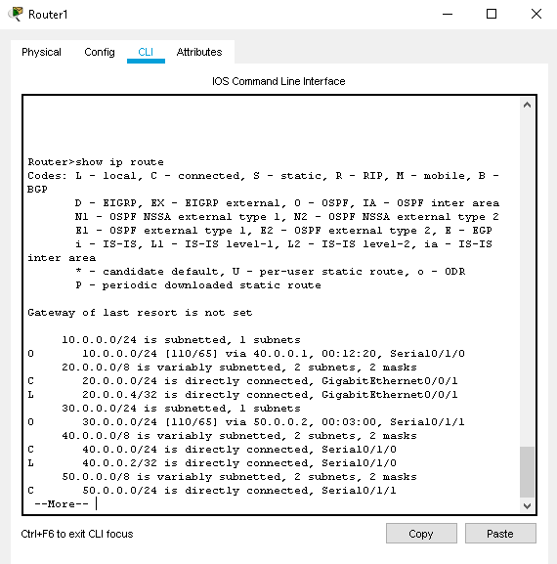

ROUTER 2

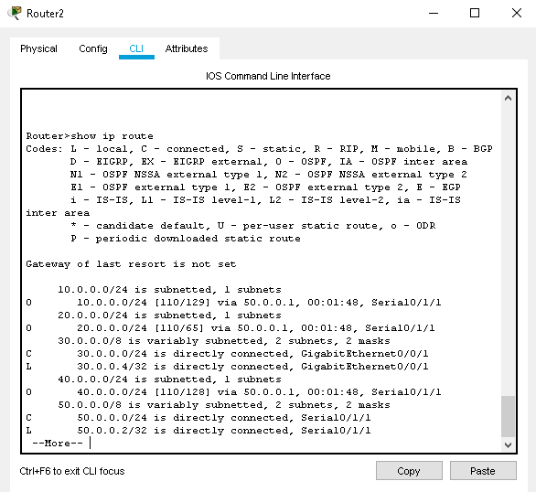

**CONCLUSION:** We have learnt to create a OSPF with three routers associated with three PC as shown above.

**PRACTICAL NO: 3**

**Aim -** Create a network with three routers with BGP and each router associated network will have minimum three PC. Show connectivity.

1. Align 9 end-devices as follows:



1. Set the DNS, Gateway and Fast Ethernet connections for all the PCs as follows: 

















1. Add 3 Switches as follows:
2. Add 3 Routers and connect all the components using Fast Ethernet connection as follows:



1. Power off each of the Routers and add the NIM-2T Module to all the Routers as follows:



1. Connect the Routers using Serial DTE wires as shown:



1. Configure Router 0 using the Command Line Interface as follows:



1. Configure Router 1 using the Command Line Interface as follows:





1. Configure Router 2 using the Command Line Interface as follows:



1. The Final connection will look as shown:



1. Note how intra-connection packet sending succeeds and inter-connection fails:









1. Configure BGP Routing in Router 0 as follows:

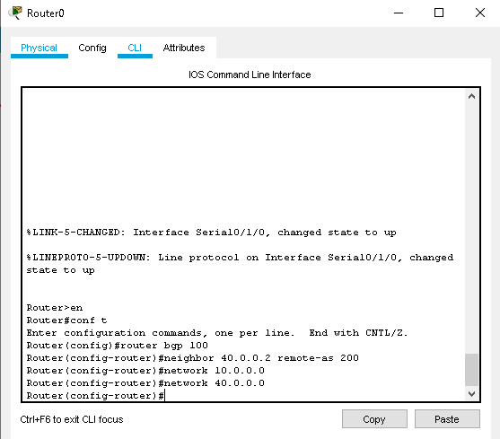

1. Configure BGP Routing in Router 1 as follows:

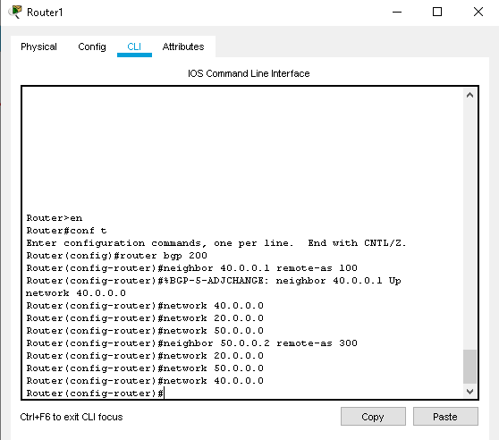

1. Configure BGP Routing in Router 2 as follows;

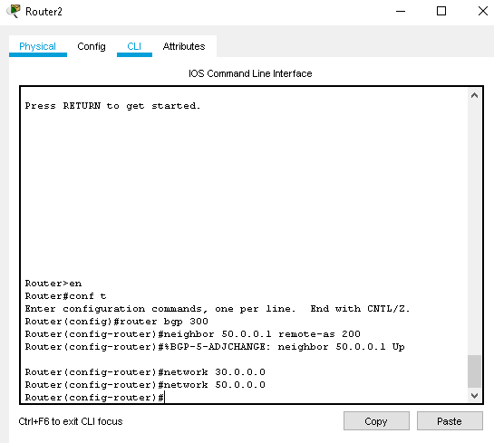

1. After successful BGP configuration, send packets over the inter-connected network :





1. Finally, in every Router’s CLI, type ‘show ip route’ to get the connection details:

ROUTER 0

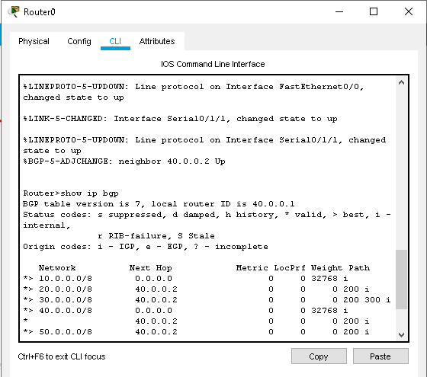

ROUTER 1

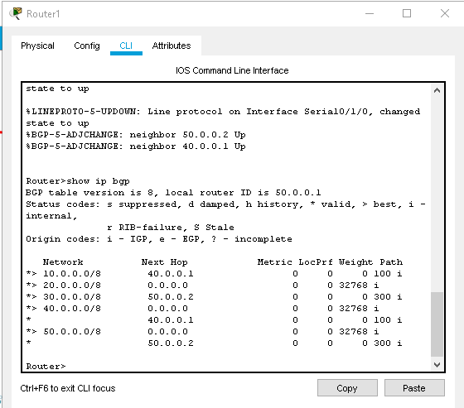

ROUTER 2

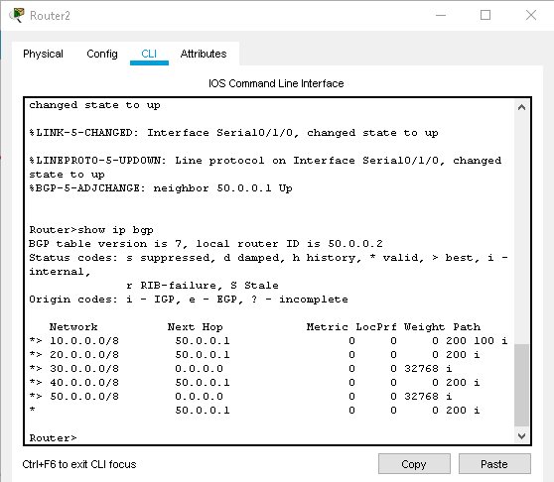

**CONCLUSION:** We have learnt to create a network with BGP with three routers as shown above.